Name: Mrs. Rupali N Hosmani.

Course: Executive Post Graduate Certification in Cloud Computing

Contact No. 7720003531

**Assignment 6 : Lambda & Beanstalk**

**A].Task to be performed:**

1. Create a sample Python Lambda function.

2. Set the Lambda Trigger as SQS and send a message to test invocation.

**B].Task to be performed:**

1. Create an Elastic Beanstalk environment with the runtime as PHP.

2. Upload a simple PHP file to the environment once created.

Steps:

1.Create a lambda function with sample python code & test it .

1. 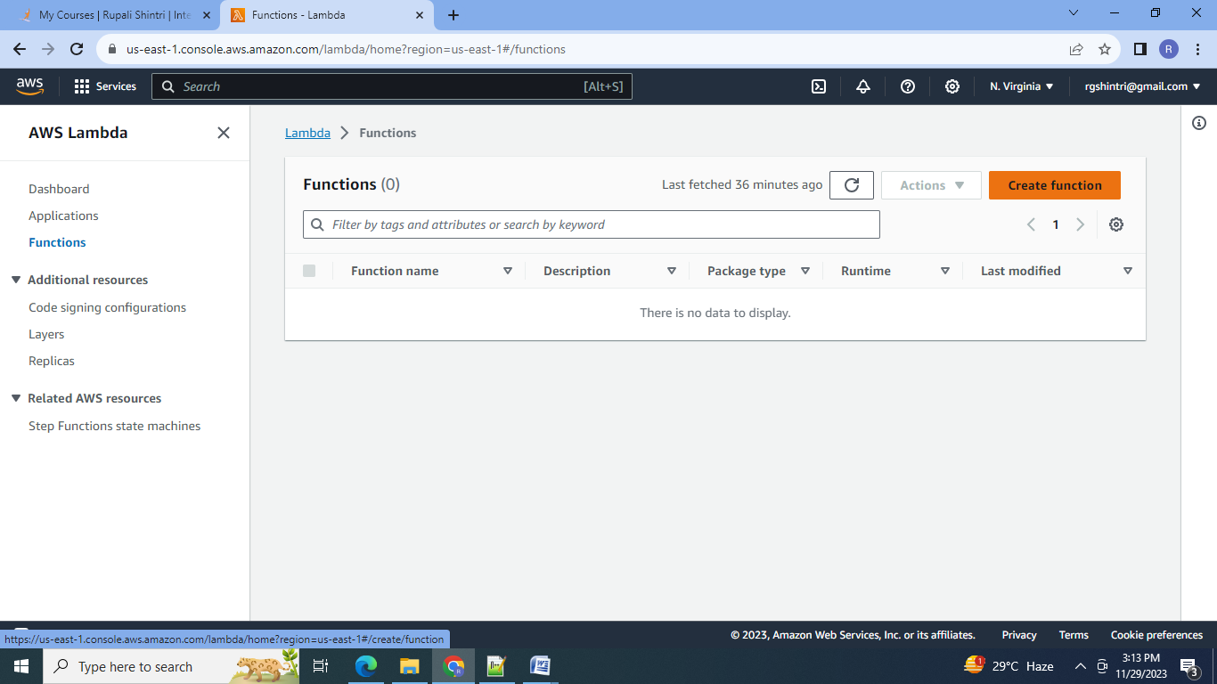

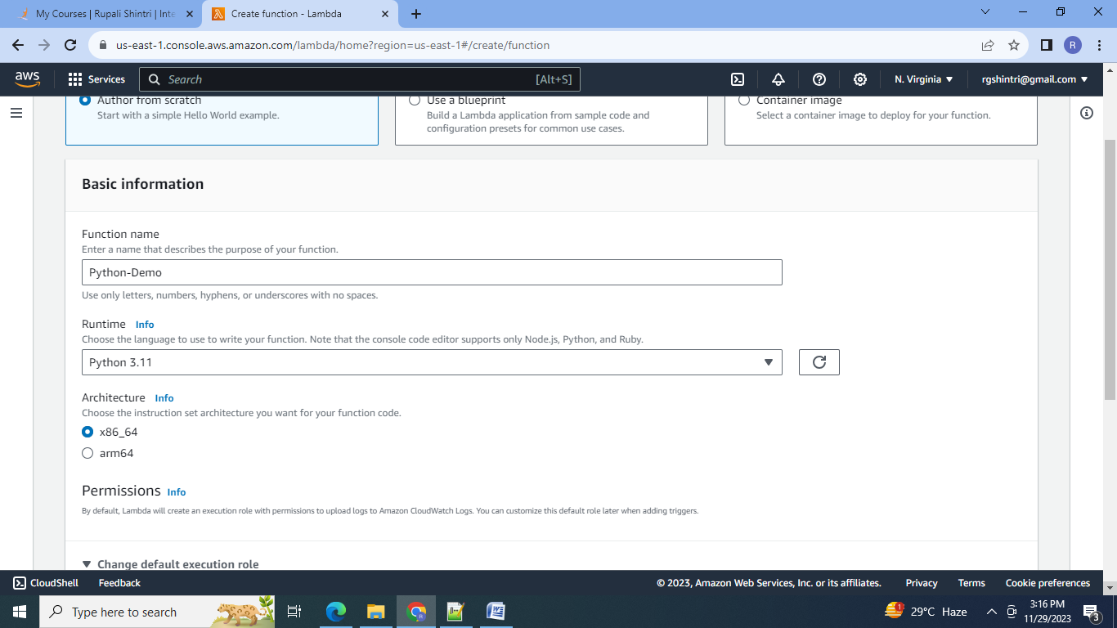

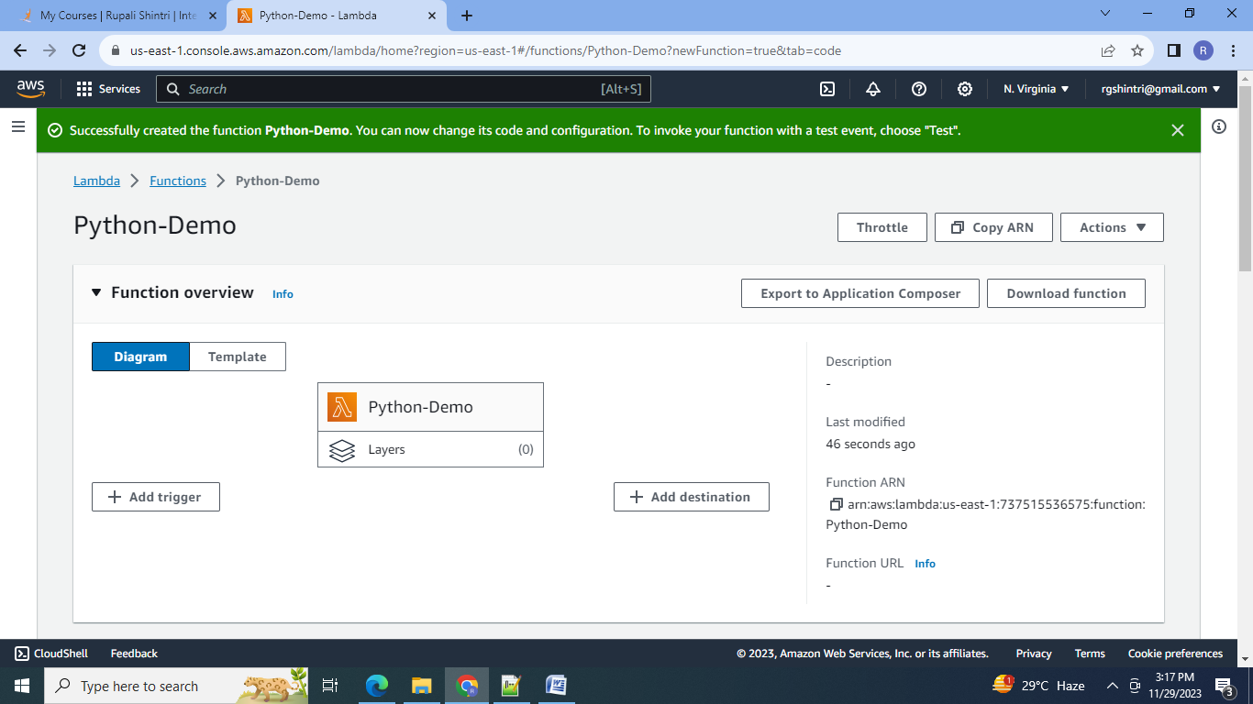

2.Test the simple addition python code:

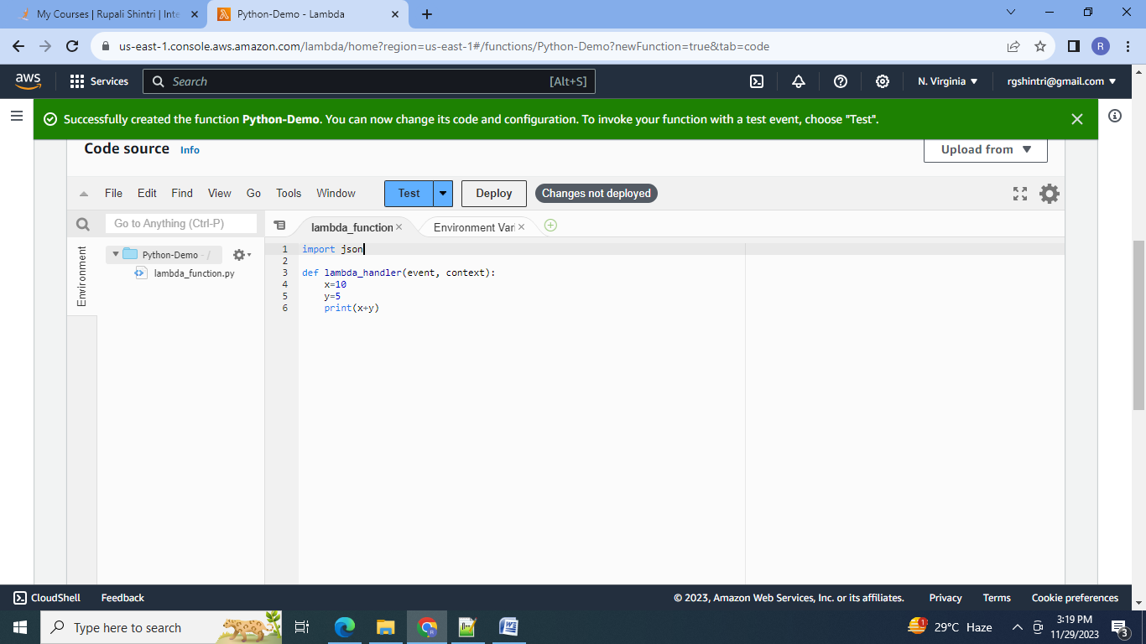

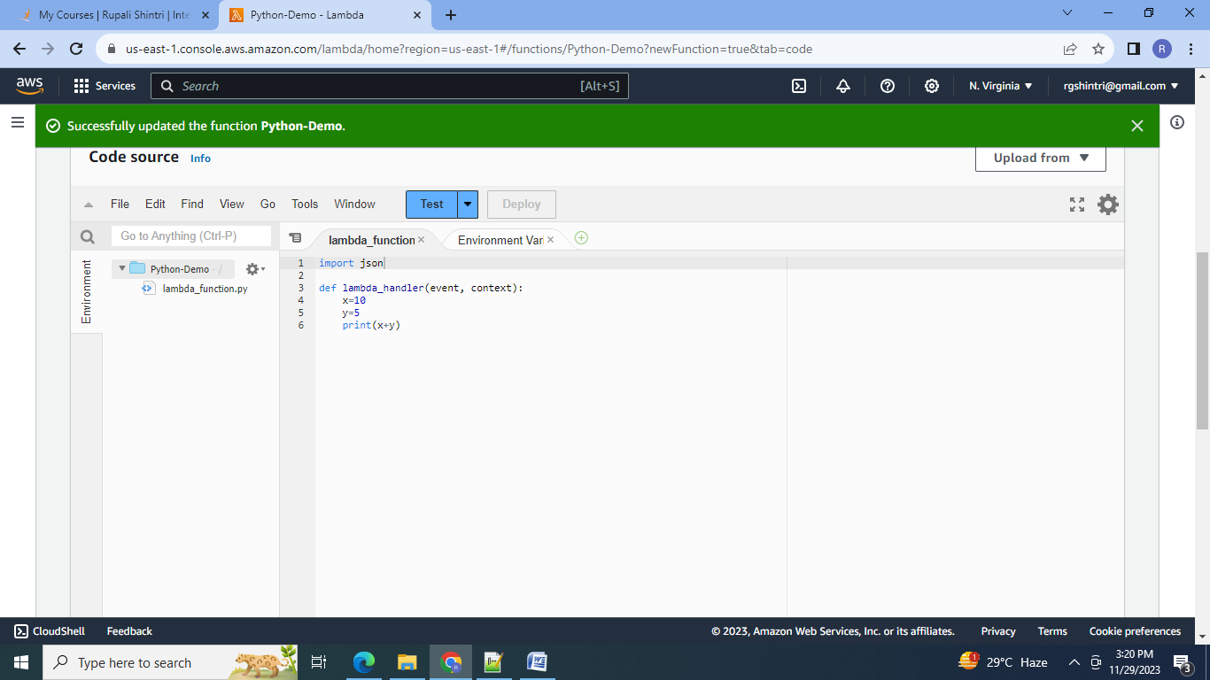

3. Create the test event:

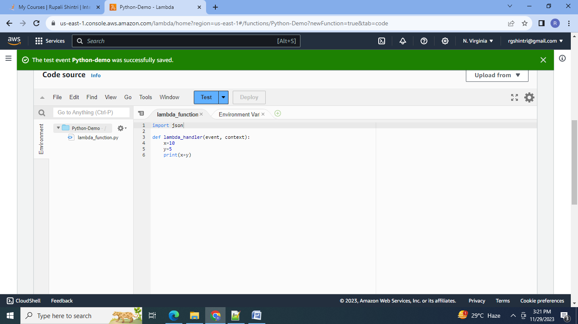

4.Test the code:

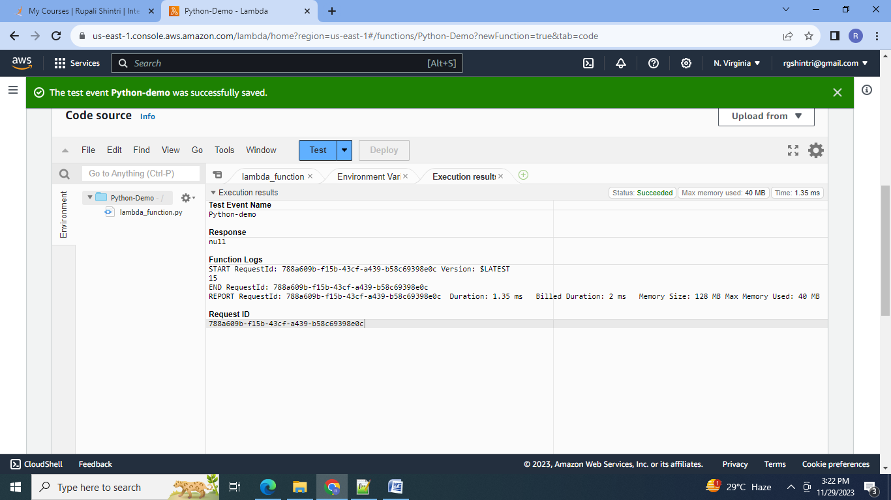

5.Monitor the log inside the cloudwatch:

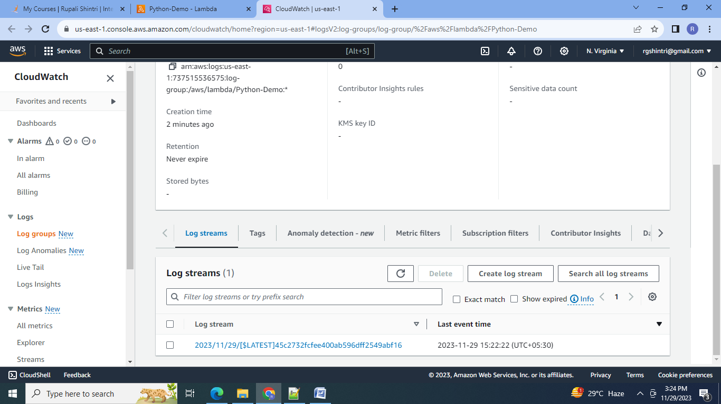

6.Log Stream:

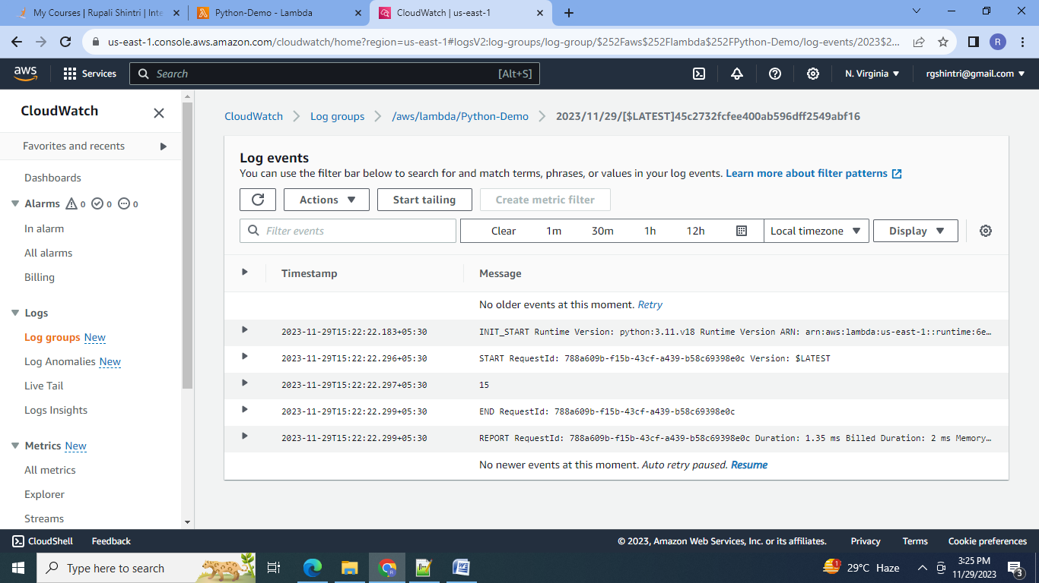

2.Set SQS as lambda trigger:

1. Create SQS:

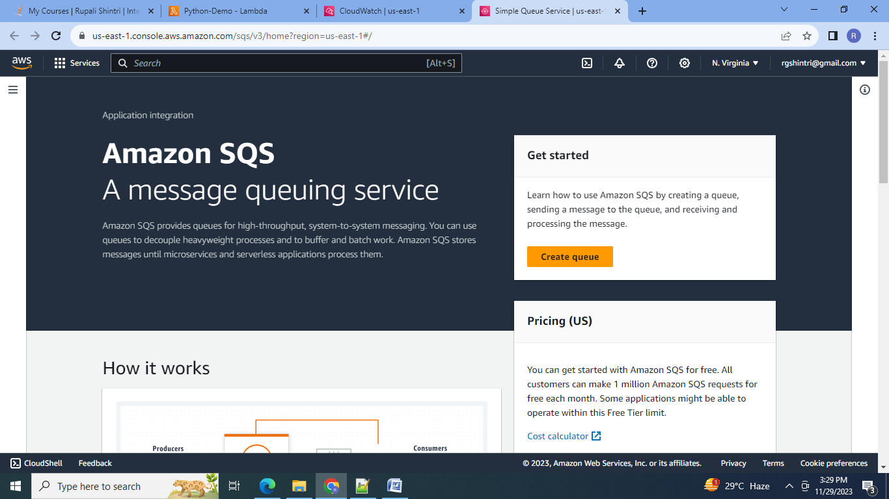

2.Create queue:

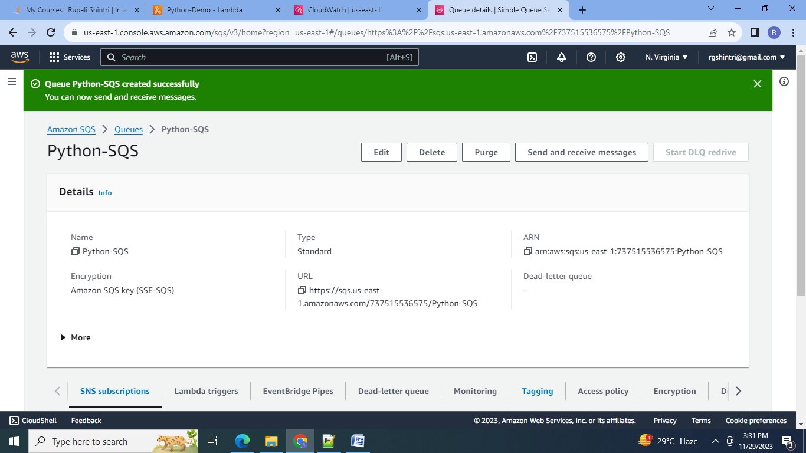

3.In lambda Add SQS trigger:

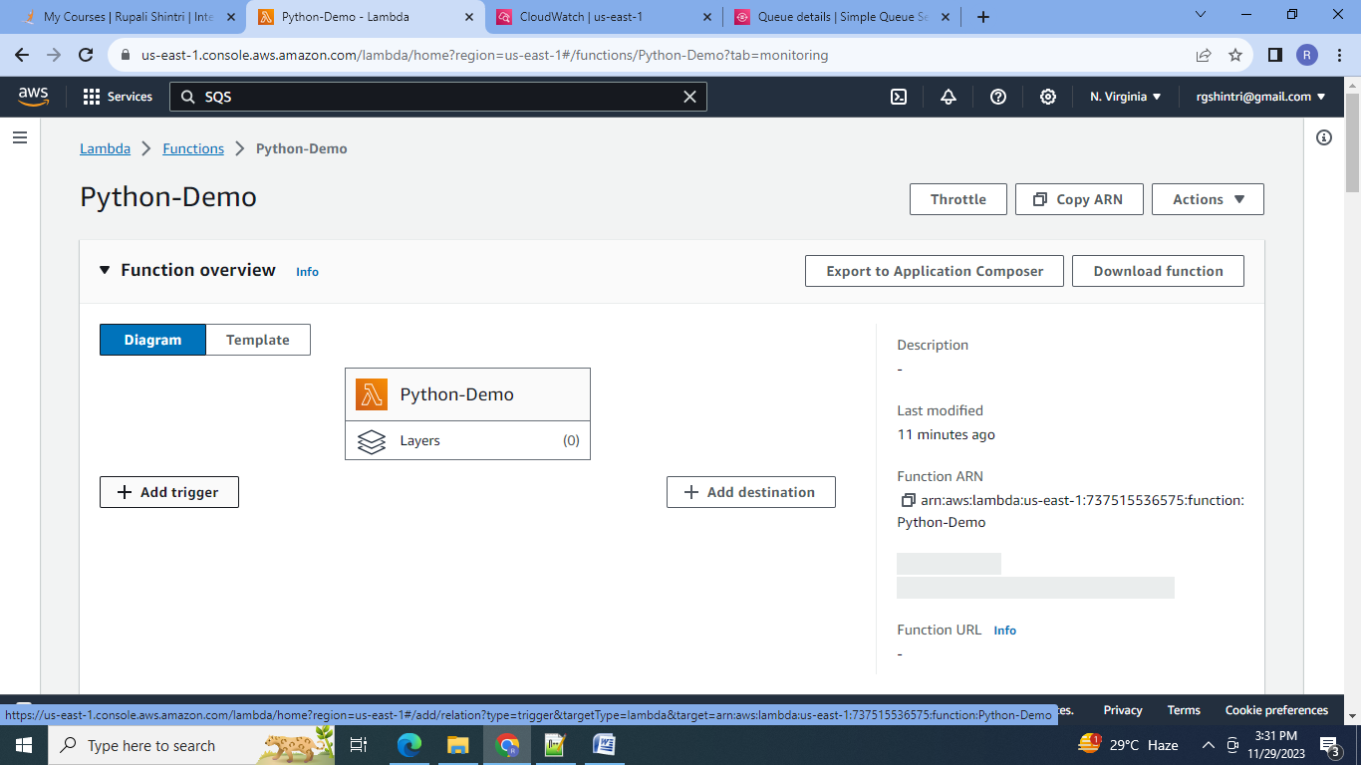

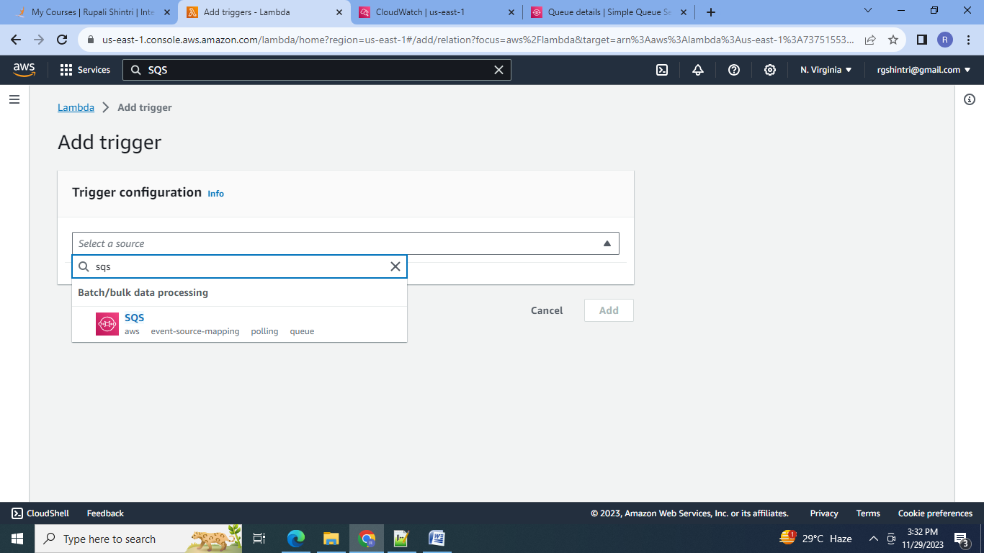

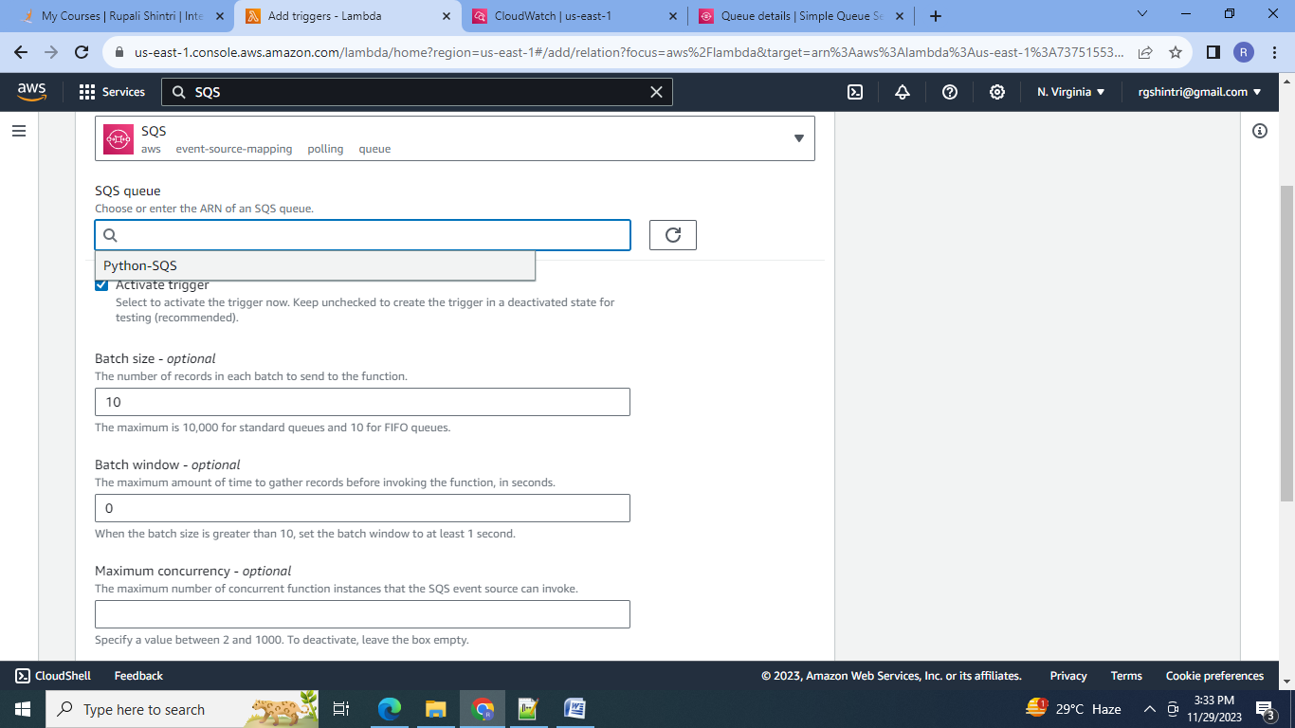

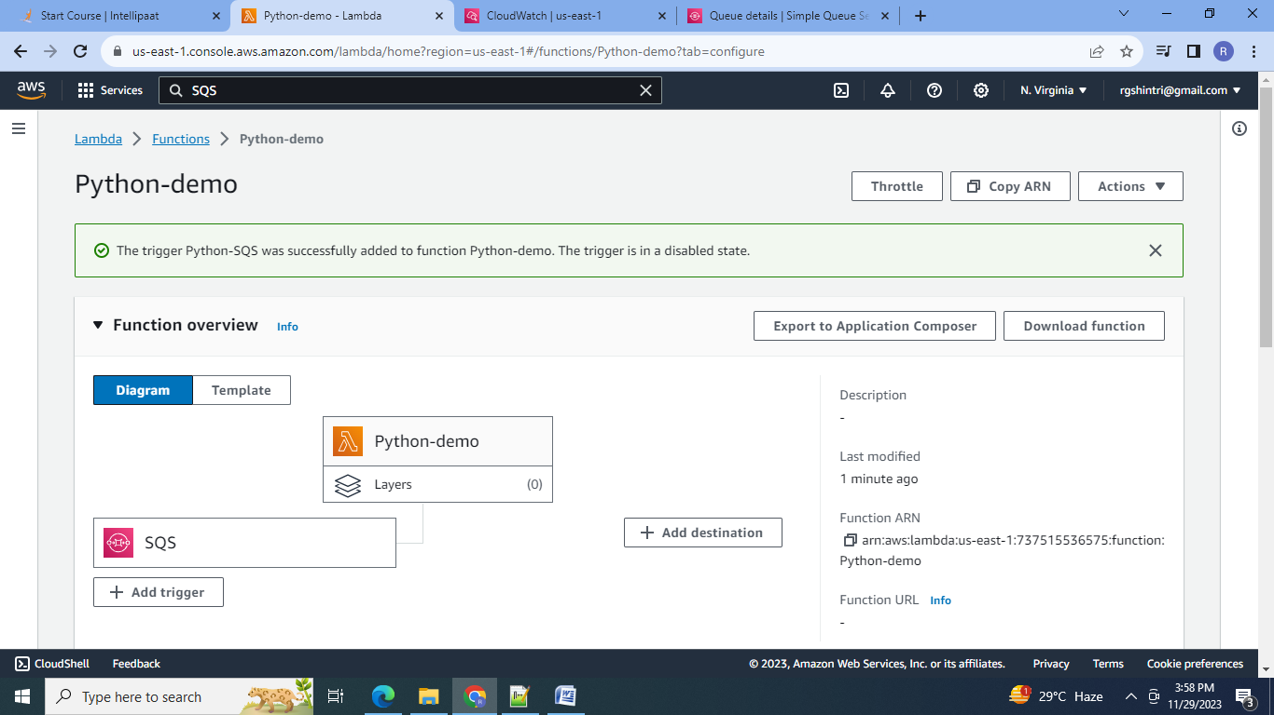

4. Change the function code to read the contents of the SQS message:

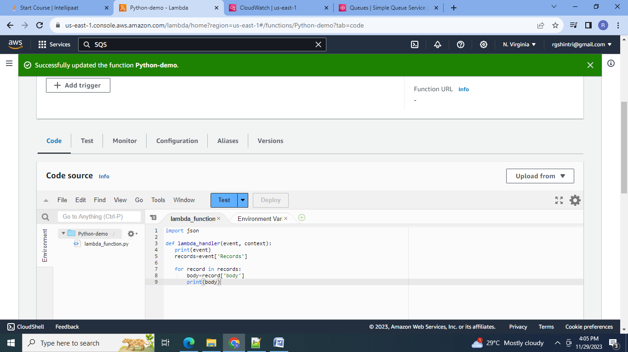

5.Create the event for SQS:

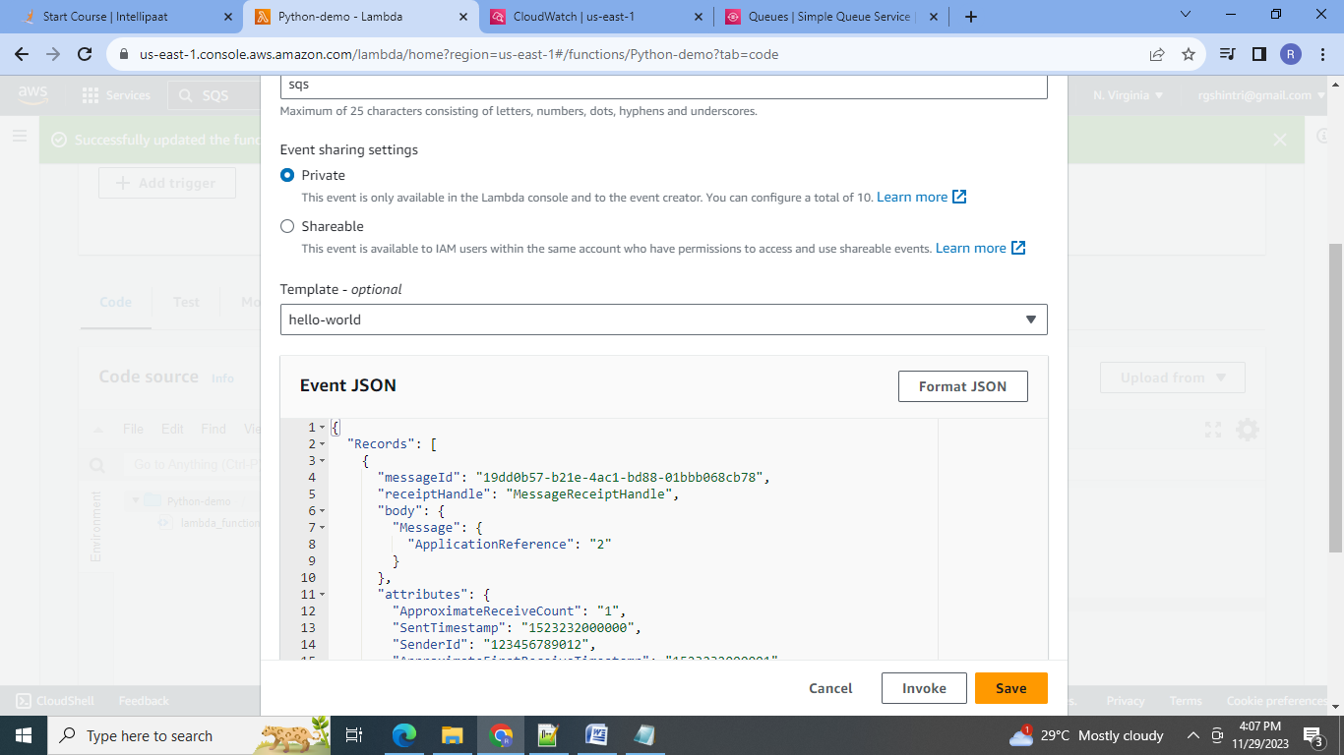

6.Test the event with lambda function:

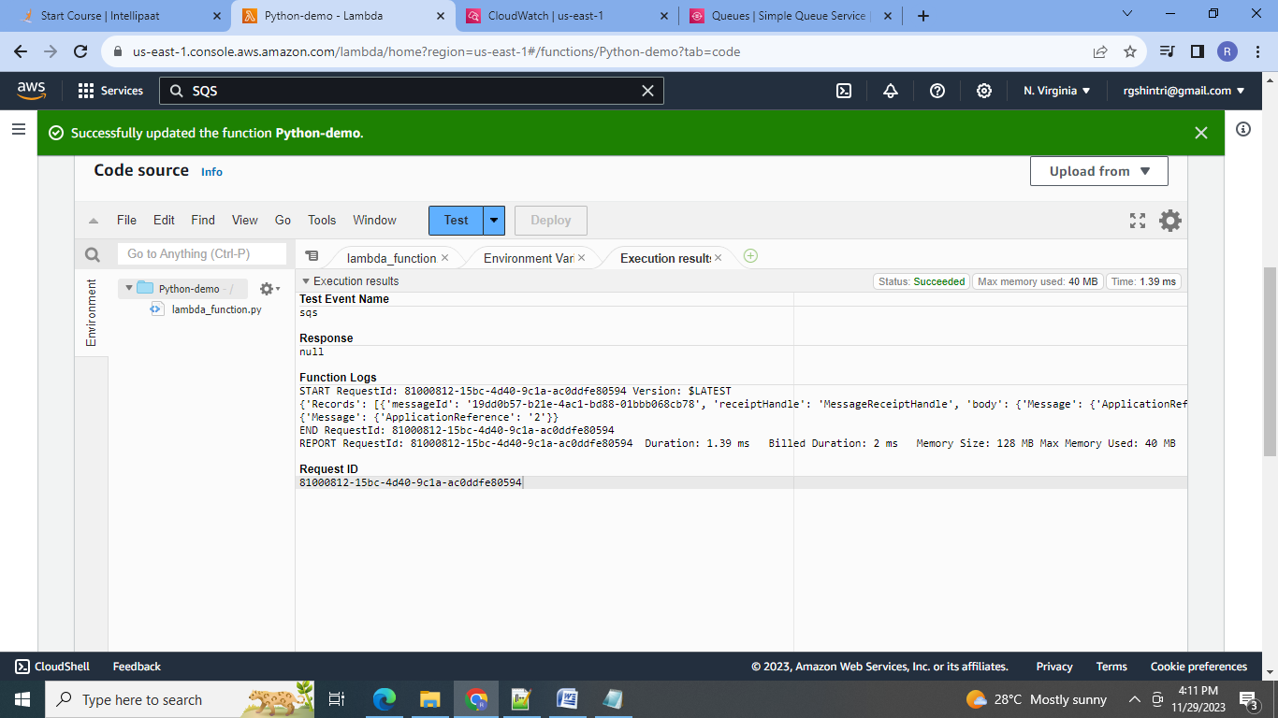

7.Send a batch of messages from SQS:

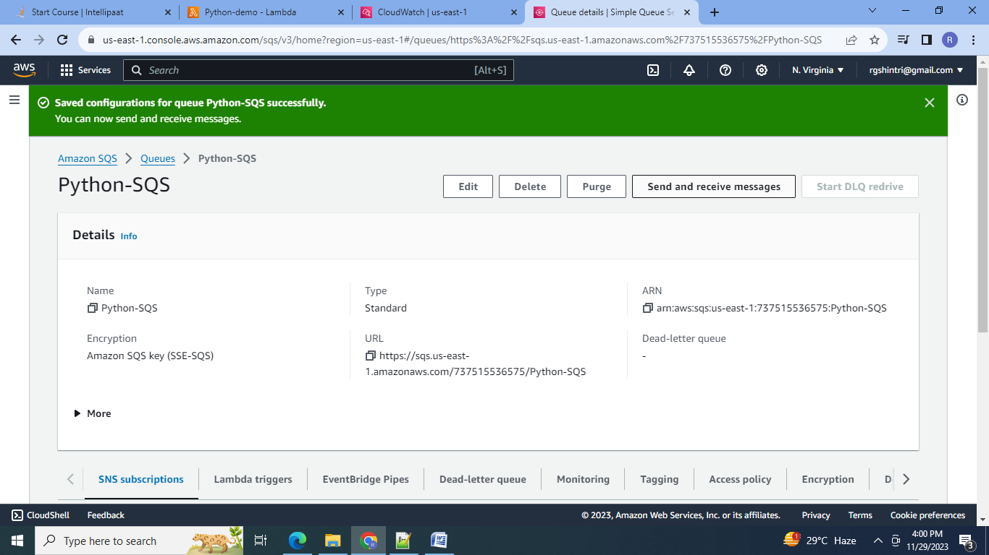

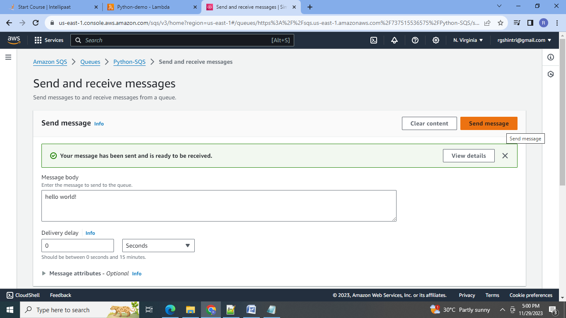

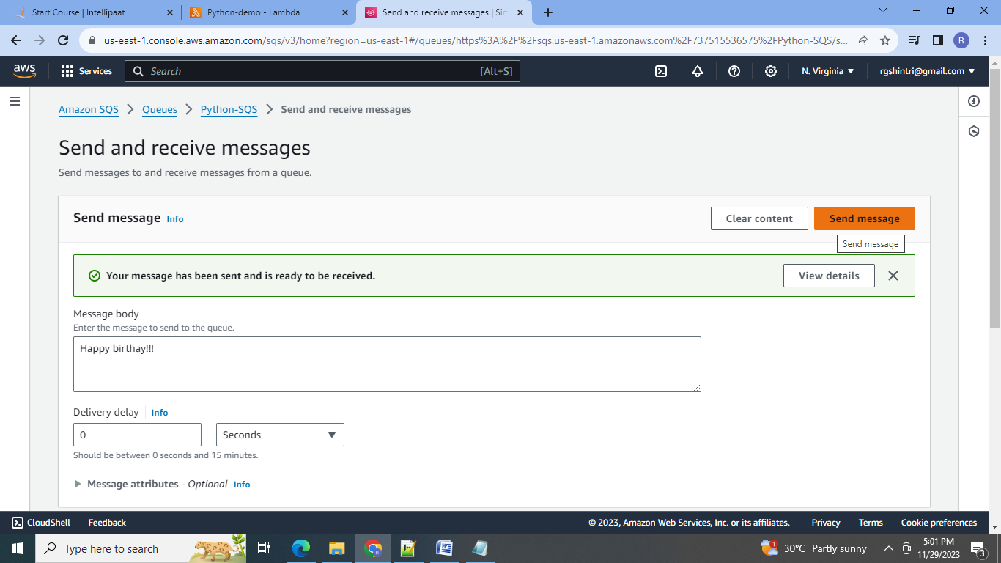

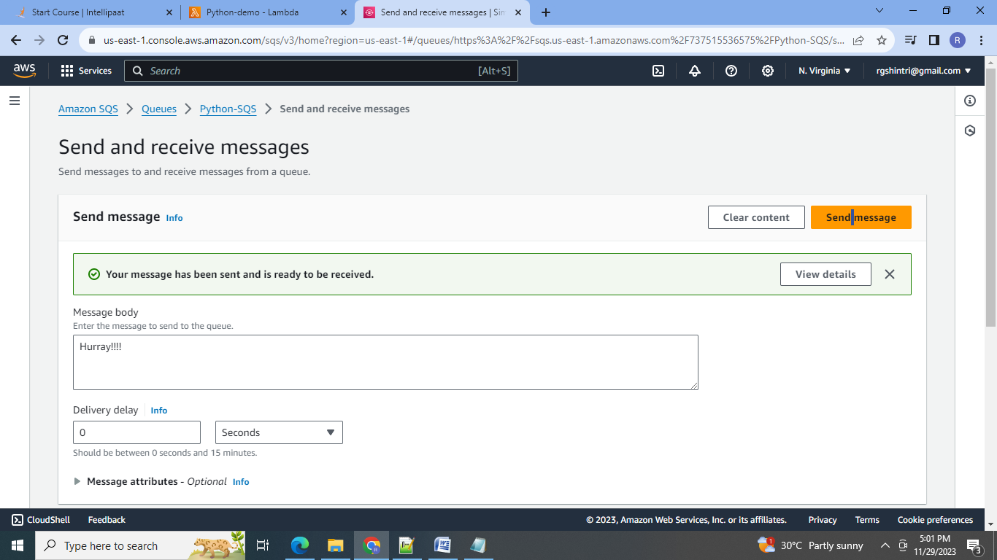

8.Go to Lambda & view the Cloudwatch logs for SQS messages.

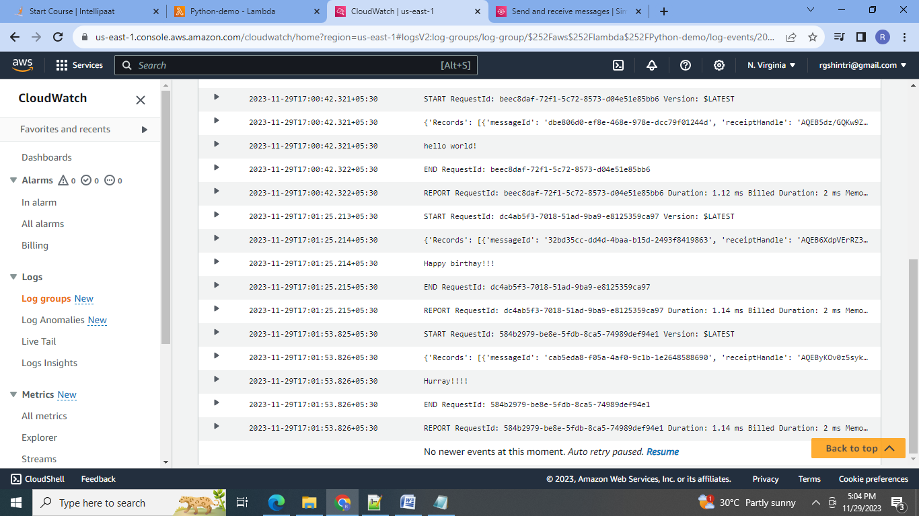

B] Steps: Create an Elastic Beanstalk environment with the runtime as PHP.

1. 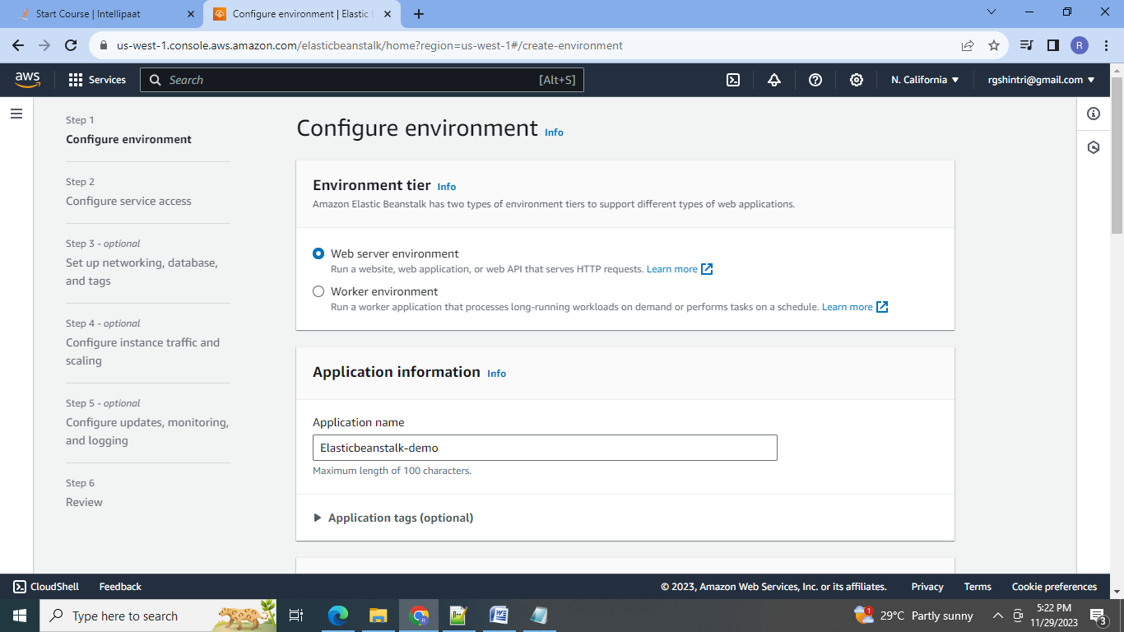

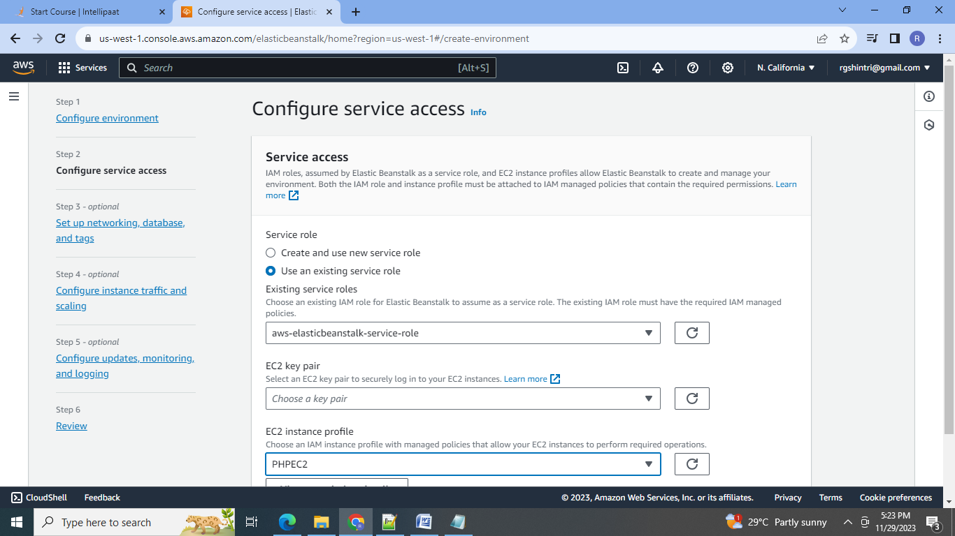

2.Crating PHP ElasticBeanstalk Evnironment:

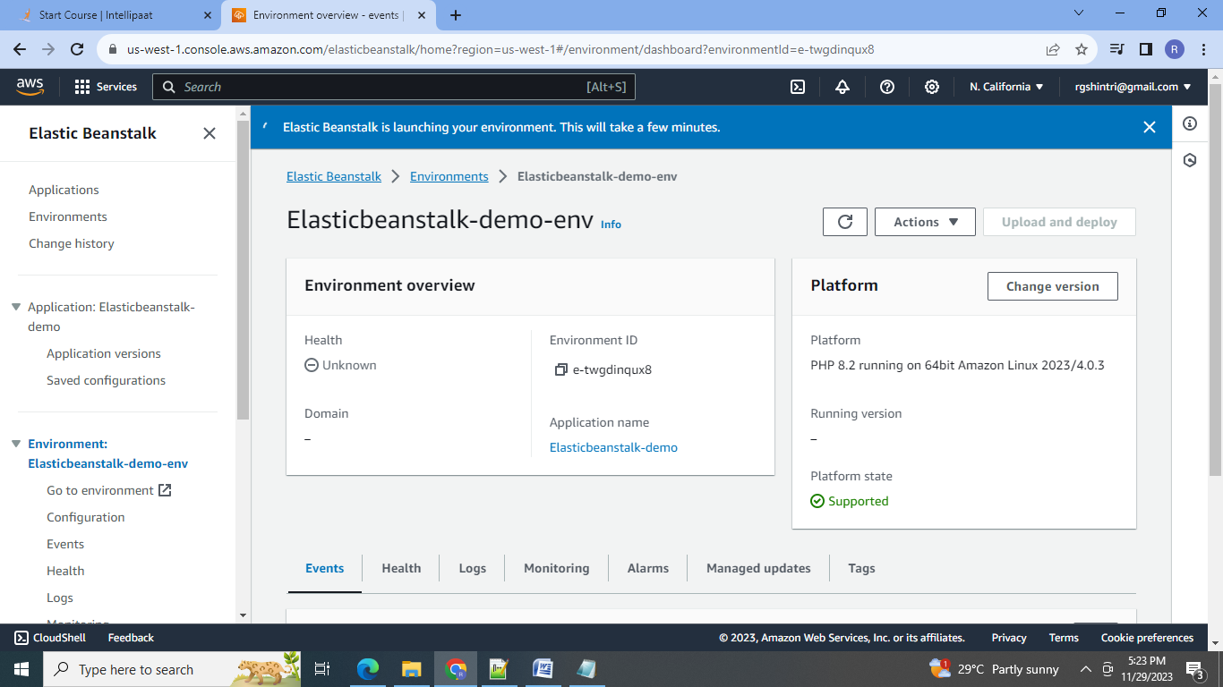

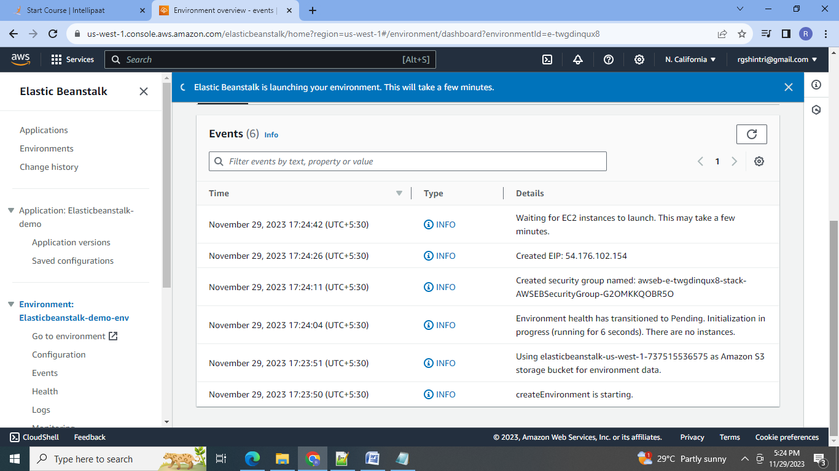

3.PHP Environment created:

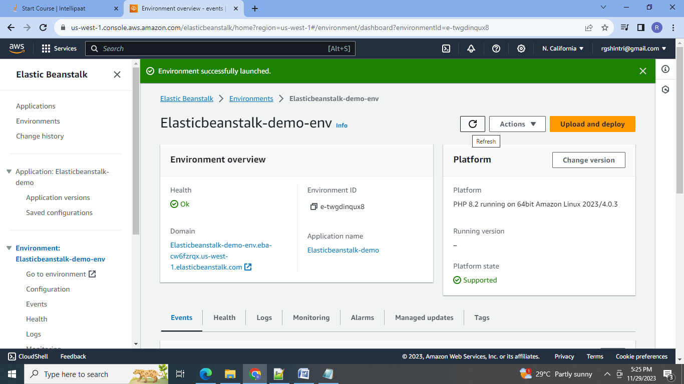

4.Test the platform for web page:

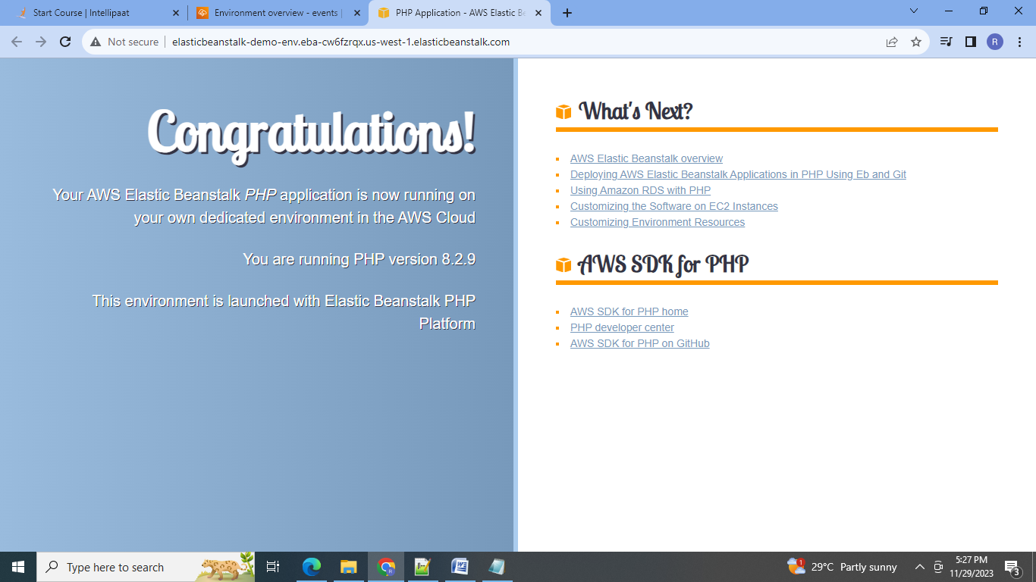

**2. Upload a simple PHP file to the environment once created.**

Step:

1.Upload & deploy new PHP file:

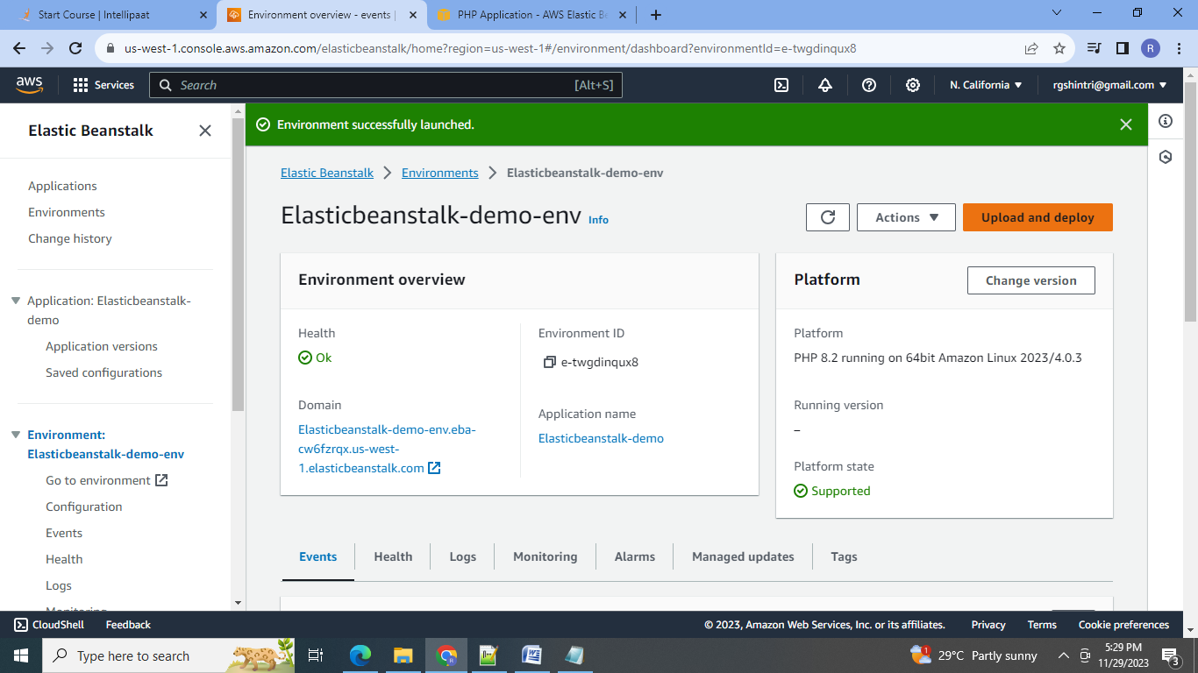

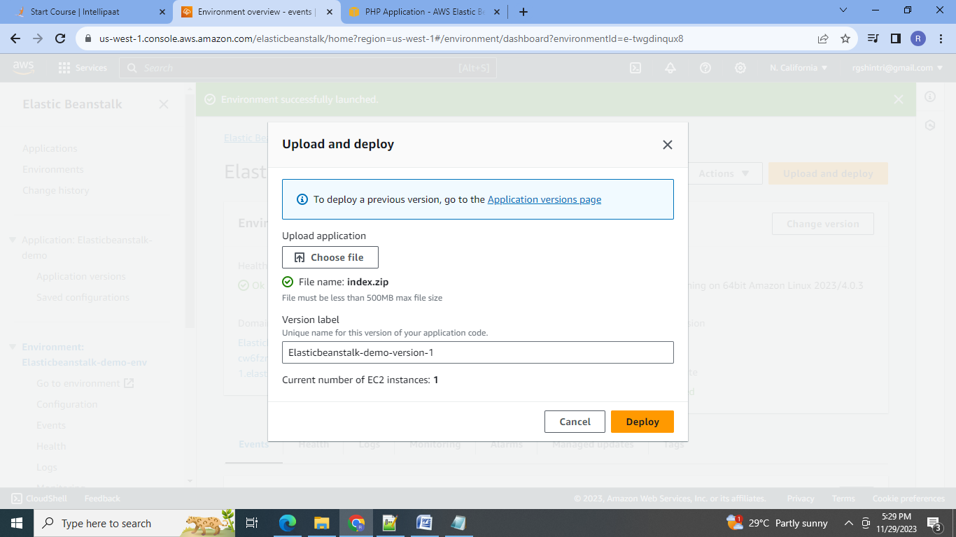

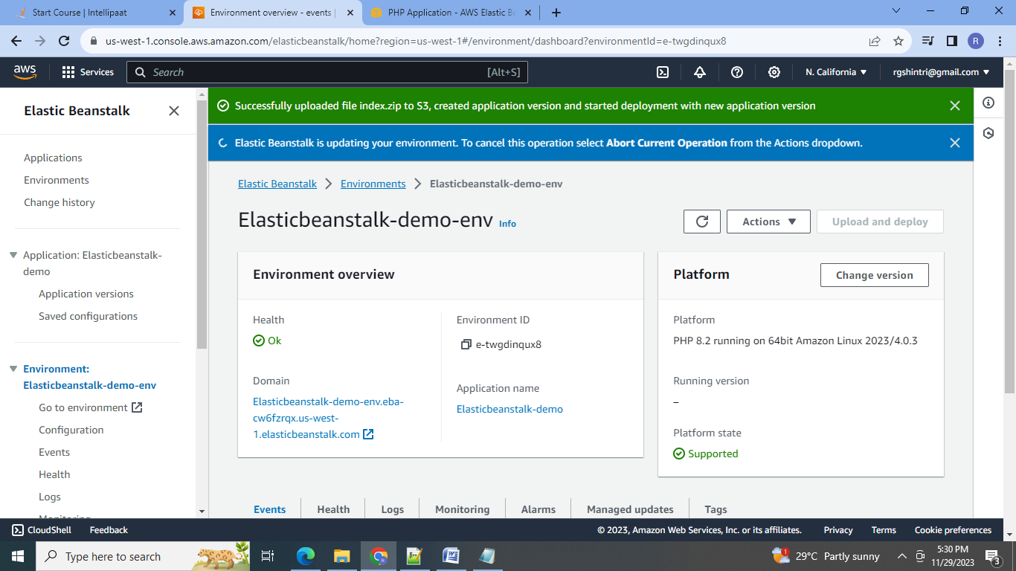

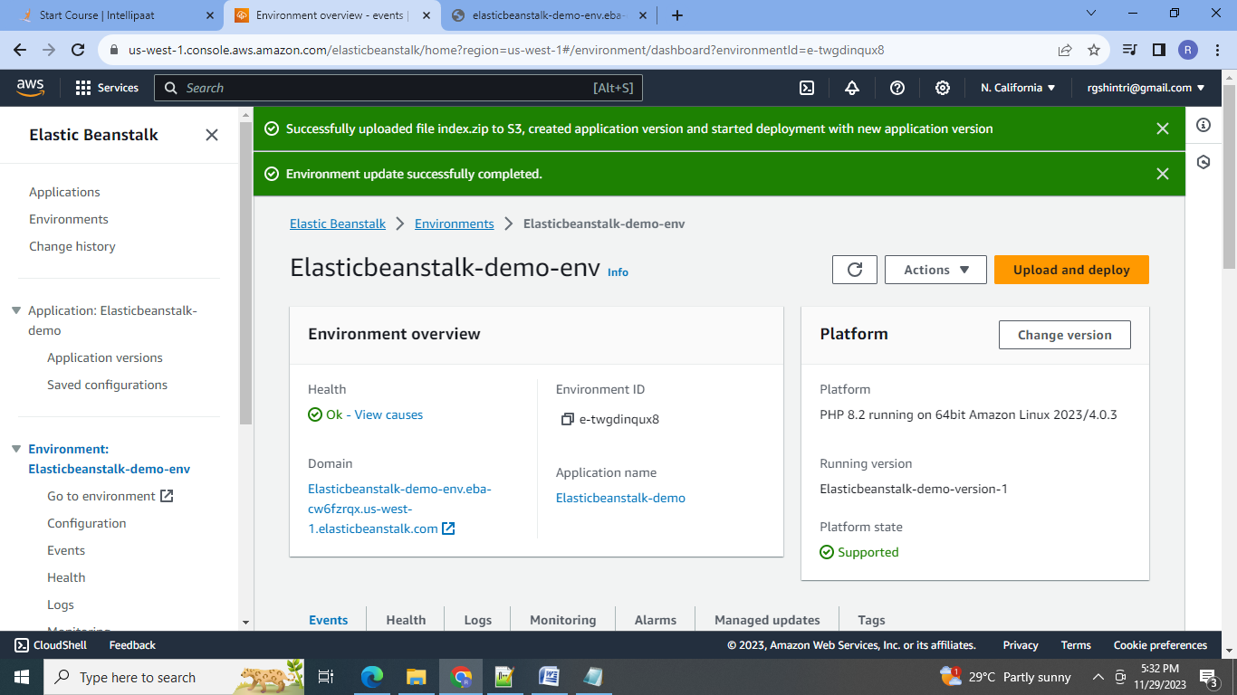

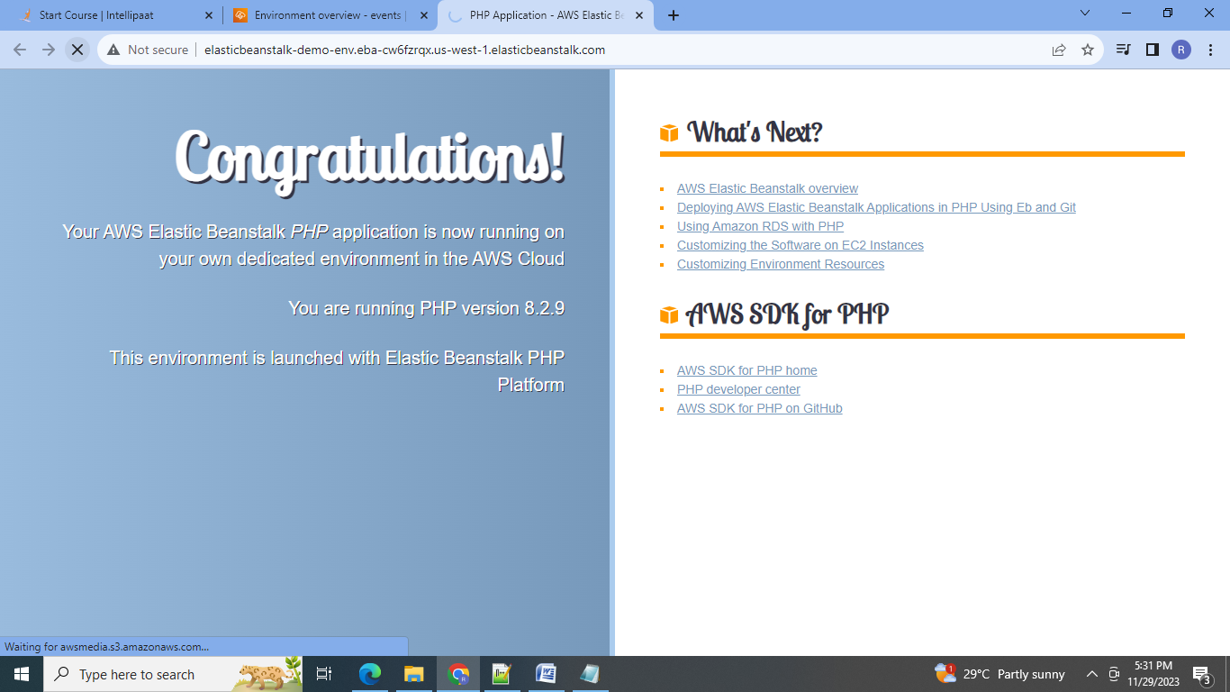

**Conclusion:**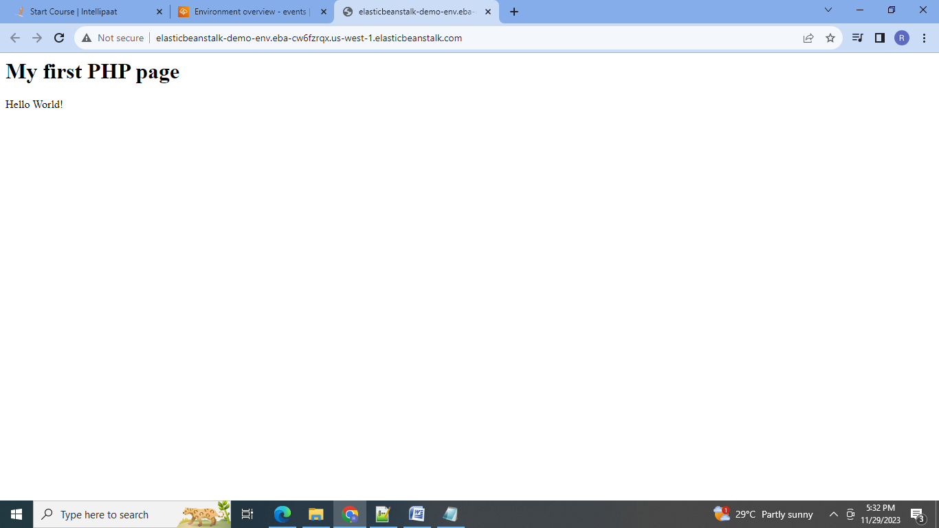 1.Using Lambda we can create a serverless applications in which code is triggered in response to the event occurrence. 2.Using ElasticBeanstalk we can create, run and manage the application without worrying about the infrastructure,

